NYCU Operation System Homework 1

IOC PhD 徐浩哲 411551005

**Part Ⅰ: Kernel compilation.**

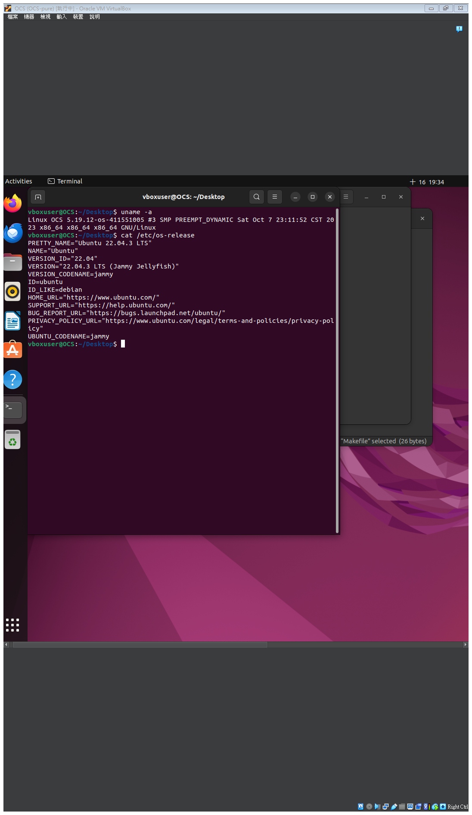

**Part Ⅱ: System call.**

* **For both System call**
  1. Creat “myFunction” folder.
  2. Creat three files named “hello.c”, “revstr.c”, and “Makefile”
  3. Add following line to “myFunction/Makefile”:



* 1. Add “/ myFunction” in “linux-5.19.12/Makefile” in line 1103:



* 1. Add the new system call to the system call table:

cd arch/x86/entry/syscalls/

add following line in syscall_64.tbl



* 1. Add new system call to the system call header file:

cd include/linux/

add following line in syscalls.h



* 1. Compile the kernel:

>sudo make -j14

>sudo make modules_install install

>sudo

* **sys_hello**

#include <linux/kernel.h>

#include <linux/syscalls.h>

SYSCALL_DEFINE0(hello)

{

printk("Hello world.\n");

printk("441551005\n");

return 0;

}



* **sys_revstr**

#include <linux/kernel.h>

#include <linux/syscalls.h>

#include <linux/uaccess.h> // for copy_from_user() and copy_to_user()

SYSCALL_DEFINE2(revstr, int, length, const char __user *, usr_str)

{

char *kern_str;

int i, j;

kern_str = kmalloc(length + 1, GFP_KERNEL);

if (!kern_str) {

return -ENOMEM;

}

// Copy string from user space to kernel space

if (copy_from_user(kern_str, usr_str, length)) {

kfree(kern_str);

return -EFAULT;

}

// Null-terminate the string

kern_str[length] = '\0';

printk(KERN_INFO "The origin string: %s\n", kern_str);

// Reverse the string

for (i = 0, j = length - 1; i < j; i++, j--) {

char temp = kern_str[i];

kern_str[i] = kern_str[j];

kern_str[j] = temp;

}

printk(KERN_INFO "The reversed string: %s\n", kern_str);

// Copy reversed string back to user space

if (copy_to_user((void __user *)usr_str, kern_str, length)) {

kfree(kern_str);

return 0;

}

kfree(kern_str);

return 0;

}

